MapReduce with MongoDB

Insert the following details into MongoDB:

Order ID | Customer | Order Date | Order Total | Item | Quantity | Unit Price | Status
1 | Ant O. Knee | 3/1/2020 | 25 | oranges | 5 | 2.5 | A
1 | Ant O. Knee | 3/1/2020 | 25 | apples | 5 | 2.5 | A
2 | Ant O. Knee | 3/8/2020 | 70 | oranges | 8 | 2.5 | A
2 | Ant O. Knee | 3/8/2020 | 70 | chocolates | 5 | 10 | A
3 | Busby Bee | 3/8/2020 | 50 | oranges | 10 | 2.5 | A
3 | Busby Bee | 3/8/2020 | 50 | pears | 10 | 2.5 | A
4 | Busby Bee | 3/18/2020 | 25 | oranges | 10 | 2.5 | A
5 | Busby Bee | 3/19/2020 | 50 | chocolates | 5 | 10 | A
6 | Cam Elot | 3/19/2020 | 35 | carrots | 10 | 1 | A
6 | Cam Elot | 3/19/2020 | 35 | apples | 10 | 2.5 | A
7 | Cam Elot | 3/20/2020 | 25 | oranges | 10 | 2.5 | A
8 | Don Quis | 3/20/2020 | 75 | chocolates | 5 | 10 | A
8 | Don Quis | 3/20/2020 | 75 | apples | 10 | 2.5 | A
9 | Don Quis | 3/20/2020 | 55 | carrots | 5 | 1 | A
9 | Don Quis | 3/20/2020 | 55 | apples | 10 | 2.5 | A
9 | Don Quis | 3/20/2020 | 55 | oranges | 10 | 2.5 | A
10 | Don Quis | 3/23/2020 | 25 | oranges | 10 | 2.5 | A

db.orders.insertMany([
{ _id: 1, cust_id: "Ant O. Knee", ord_date: new Date("2020-03-01"), price: 25, items: [ { sku: "oranges", qty: 5, price: 2.5 }, { sku: "apples", qty: 5, price: 2.5 } ], status: "A" },
{ _id: 2, cust_id: "Ant O. Knee", ord_date: new Date("2020-03-08"), price: 70, items: [ { sku: "oranges", qty: 8, price: 2.5 }, { sku: "chocolates", qty: 5, price: 10 } ], status: "A" },
{ _id: 3, cust_id: "Busby Bee", ord_date: new Date("2020-03-08"), price: 50, items: [ { sku: "oranges", qty: 10, price: 2.5 }, { sku: "pears", qty: 10, price: 2.5 } ], status: "A" },
{ _id: 4, cust_id: "Busby Bee", ord_date: new Date("2020-03-18"), price: 25, items: [ { sku: "oranges", qty: 10, price: 2.5 } ], status: "A" },
{ _id: 5, cust_id: "Busby Bee", ord_date: new Date("2020-03-19"), price: 50, items: [ { sku: "chocolates", qty: 5, price: 10 } ], status: "A"},
{ _id: 6, cust_id: "Cam Elot", ord_date: new Date("2020-03-19"), price: 35, items: [ { sku: "carrots", qty: 10, price: 1.0 }, { sku: "apples", qty: 10, price: 2.5 } ], status: "A" },
{ _id: 7, cust_id: "Cam Elot", ord_date: new Date("2020-03-20"), price: 25, items: [ { sku: "oranges", qty: 10, price: 2.5 } ], status: "A" },
{ _id: 8, cust_id: "Don Quis", ord_date: new Date("2020-03-20"), price: 75, items: [ { sku: "chocolates", qty: 5, price: 10 }, { sku: "apples", qty: 10, price: 2.5 } ], status: "A" },
{ _id: 9, cust_id: "Don Quis", ord_date: new Date("2020-03-20"), price: 55, items: [ { sku: "carrots", qty: 5, price: 1.0 }, { sku: "apples", qty: 10, price: 2.5 }, { sku: "oranges", qty: 10, price: 2.5 } ], status: "A" },
{ _id: 10, cust_id: "Don Quis", ord_date: new Date("2020-03-23"), price: 25, items: [ { sku: "oranges", qty: 10, price: 2.5 } ], status: "A" }
])

Return the Total Price Per Customer
Perform the map-reduce operation on the orders collection to group by the cust_id, and calculate the sum of the price for each cust_id:
- Define the map function to process each input document:
  - In the function, this refers to the document that the map-reduce operation is processing.
  - The function maps the price to the cust_id for each document and emits the cust_id and price.
var mapFunction1 = function() {
emit(this.cust_id, this.price);
};
• Define the corresponding reduce function with two arguments keyCustId and valuesPrices:
- The valuesPrices is an array whose elements are the price values emitted by the map function and grouped by keyCustId.
- The function reduces the valuesPrice array to the sum of its elements.
var reduceFunction1 = function(keyCustId, valuesPrices) {
return Array.sum(valuesPrices);
};
Perform map-reduce on all documents in the orders collection using the mapFunction1 map function and the reduceFunction1 reduce function:
db.orders.mapReduce(
mapFunction1,
reduceFunction1,
{ out: "map_reduce_example" }
)
• This operation outputs the results to a collection named map_reduce_example. If the map_reduce_example collection already exists, the operation will replace the contents with the results of this map-reduce operation.
• Query the map_reduce_example collection to verify the results:
db.map_reduce_example.find().sort( { _id: 1 } )
- The operation returns these documents:
{ "_id" : "Ant O. Knee", "value" : 95 }
{ "_id" : "Busby Bee", "value" : 125 }
{ "_id" : "Cam Elot", "value" : 60 }
{ "_id" : "Don Quis", "value" : 155 }

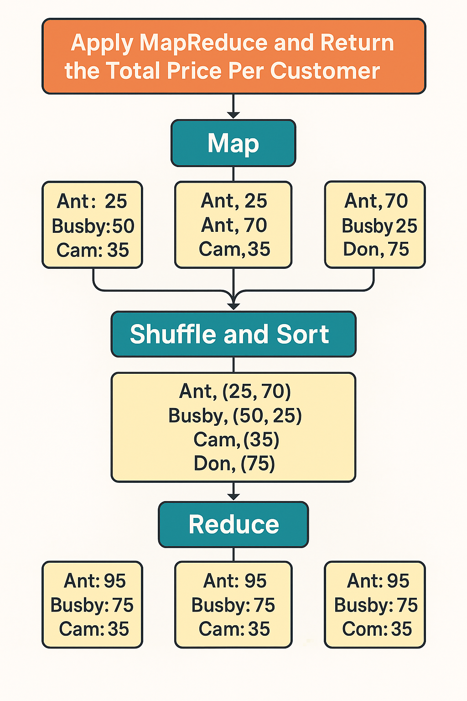

Aggregation Alternative
Using the available aggregation pipeline operators, you can rewrite the map-reduce operation without defining custom functions:
db.orders.aggregate([
{ $group: { _id: "$cust_id", value: { $sum: "$price" } } },
{ $out: "agg_alternative_1" }
])
• The $group stage groups by the cust_id and calculates the value field (See also $sum). The value field contains the total price for each cust_id.
The stage output the following documents to the next stage:
{ "_id" : "Don Quis", "value" : 155 }
{ "_id" : "Ant O. Knee", "value" : 95 }
{ "_id" : "Cam Elot", "value" : 60 }
{ "_id" : "Busby Bee", "value" : 125 }
• Then, the $out writes the output to the collection agg_alternative_1. Alternatively, you could use $merge instead of $out.
• Query the agg_alternative_1 collection to verify the results:
db.agg_alternative_1.find().sort( { _id: 1 } )
- The operation returns the following documents:
{ "_id" : "Ant O. Knee", "value" : 95 }
{ "_id" : "Busby Bee", "value" : 125 }
{ "_id" : "Cam Elot", "value" : 60 }
{ "_id" : "Don Quis", "value" : 155 }

